Ideation Phase
Brainstorm & Idea Prioritization Template

Date | 31 Oct 2025
Team ID | NM2025TMID01169
Project Name | LAPTOP REQUEST CATALOG ITEM
Maximum Marks | 4 Marks

Brainstorm & Idea Prioritization Template:
The goal of our 'Laptop Request Catalog Item' project, which involves brainstorming and idea prioritization, is to replace the manual and time-consuming laptop request procedure with a dynamic, fast, and efficient ServiceNow Service Catalog experience. In order to capture every potential improvement for precise data collecting and an easy-to-use user interface, we first prioritize volume over value as we cooperatively produce a wide range of suggestions for variables, dynamic UI regulations, approval workflows, and user advice. This entails investigating the most effective ways to incorporate reset functionality, clear instructions, and dynamic form behavior. In order to choose the most practical and impactful solutions for development, we will first assess these concepts using a systematic prioritization process. This will guarantee that the project produces a truly user-centric and error-reducing solution that greatly raises employee satisfaction and operational efficiency.

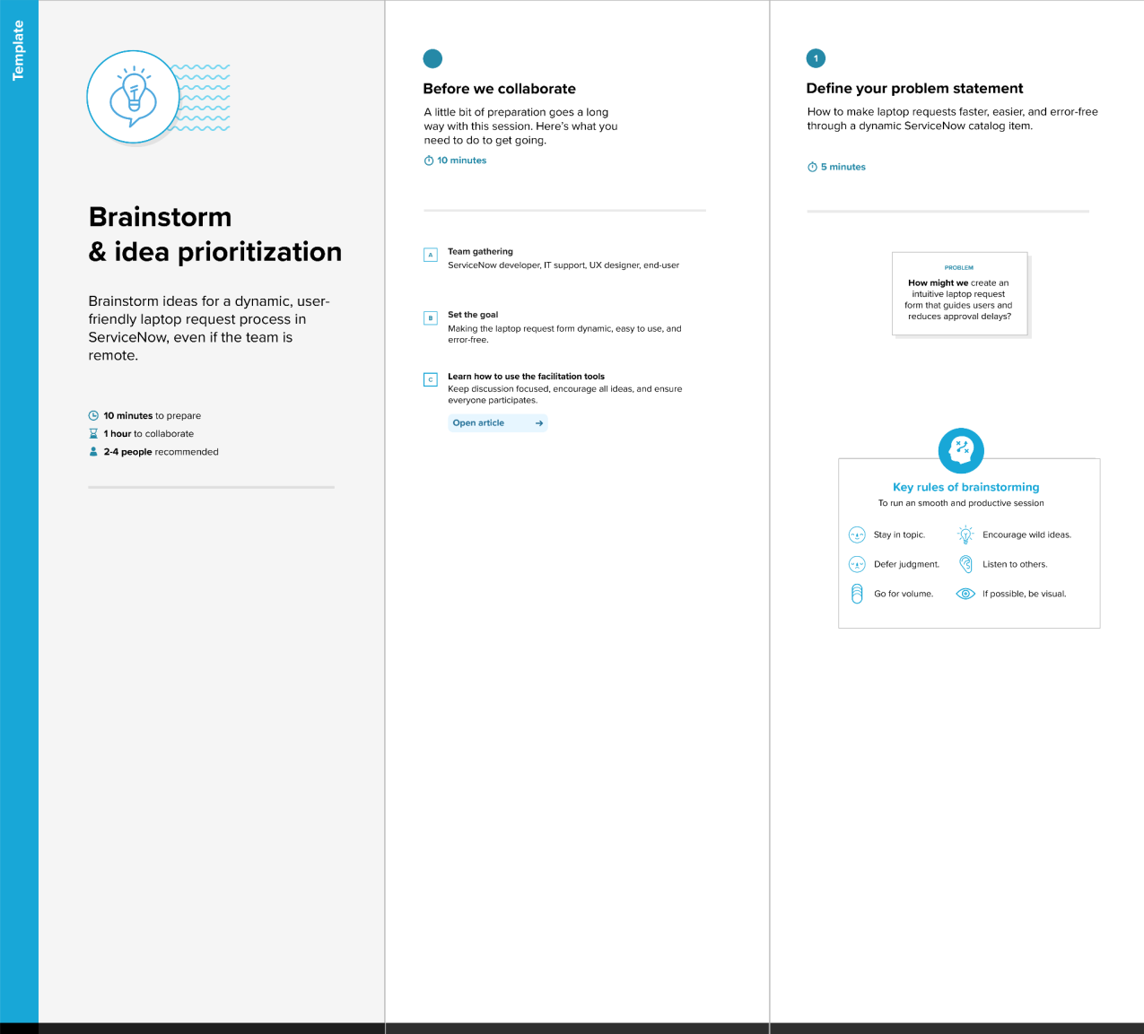
Step-1: Team Gathering, Collaboration and Select the Problem Statement
Step-2: Brainstorm, Idea Listing and Grouping
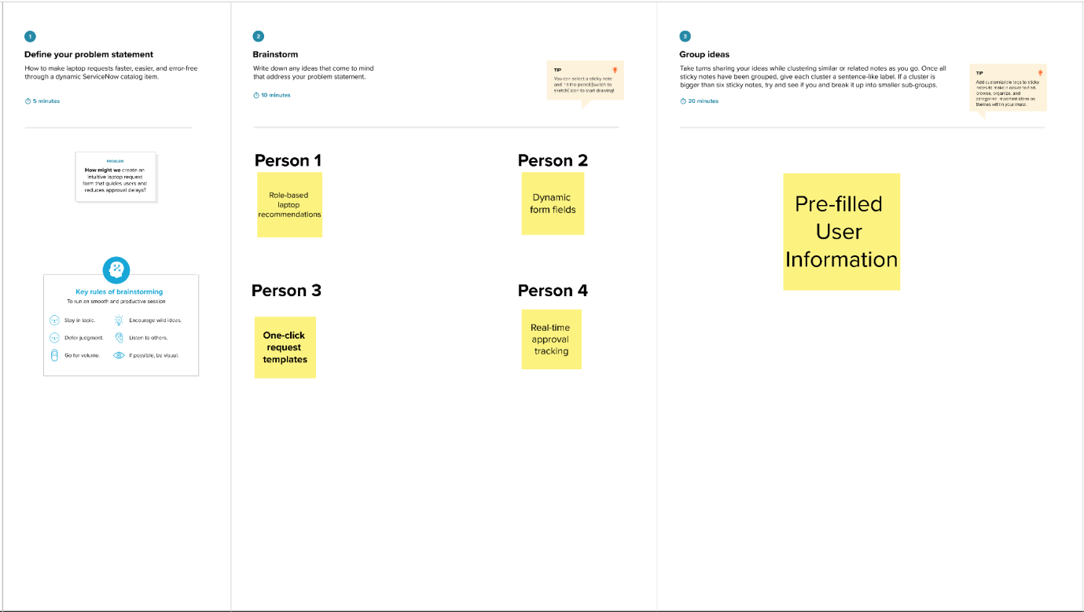

Step-3: Idea Prioritization
